Truss Project

TU23FL-CAD

Dr. Laura Riggio

Jakob Werle

2023-10-08

# Introduction

This project entails designing a truss that can support given point loads and deflect a maximum of 0.01% of its overall dimensions. The stresses in each member and nodal displacement will be analyzed with a static SOLIDWORKS simulation to confirm the truss is viable for the given conditions. The truss geometry and cross section will be altered to explore how different parameters can affect the design of a truss.

# Procedure

To perform a truss structural analysis with SOLIDWORKS, first a model must be created. Then, the simulation constraints can be set up. Finally, the simulation can be run, and results should be tailored to analyze particular things.

Effectively modeling a truss can be done with a 2D sketch and weldments. On the front plane, a sketch was created with lines drawn in the shape of the desired truss. In a separate file, the member profile was sketched and saved as a Library Feature Part in the local weldment profile file location. A weldment was created using the custom weldment profile and corner treatments were left off. The 3D modeled truss would then be ready for analysis.

The first step in setting up a SOLIDWORKS simulation for trusses was to define the members as “Truss” elements. This setting only allowed elemental behavior to act axially, neglecting bending and shearing. Since the truss study is only in 2D, all nodes were constrained coincidently to the front plane to limit all movement to the X and Y axes. Supported nodes 1 and 5 were constrained appropriately to match the style of support. It should be noted that rotation was not limited along the Z axis since truss elements need to be free to rotate to allow nodal translation. Nodes 2 and 4 were applied with point loads in their respective X and Y components.

|  |  |
| --- | --- |
|  |  |

The truss simulation was then meshed and ran. To confirm the simulation ran properly, resultant forces and element shear stresses were probed and compared to hand calculations. Nodal displacements can be evaluated in their X and Y components by changing the definition of the “Displacement” results. This process was reiterated several times after making attempts to improve the geometry design of the truss.

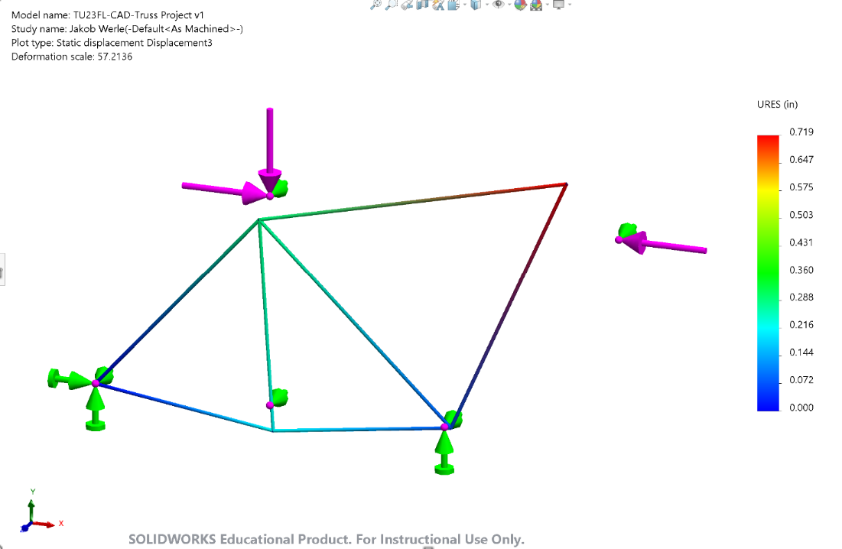

# Results

|  |  |  |  |  |  |  |
| --- | --- | --- | --- | --- | --- | --- |
| **Table 1 - Iteration 1 Statics Validation** | | | | | | |
| **Node** | **Hand Calc** | | **SOLIDWORKS** | | **% Difference** | |
| **F_X (lbf)** | **F_Y (lbf)** | **F_X (lbf)** | **F_Y (lbf)** | **X** | **Y** |
| **1** | 70000 | 122000 | 70000 | 122000 | 0% | 0% |
| **2** | 130000 | -160000 | 130000 | -160000 | 0% | 0% |
| **3** | 0 | 0 | 0 | 0 | 0% | 0% |
| **4** | -200000 | 0 | -200000 | 0 | 0% | 0% |
| **5** | 0 | 38000 | 0 | 38000 | 0% | 0% |

Table 1 compares the resultant forces calculated by hand and by SOLIDWORKS at each node.

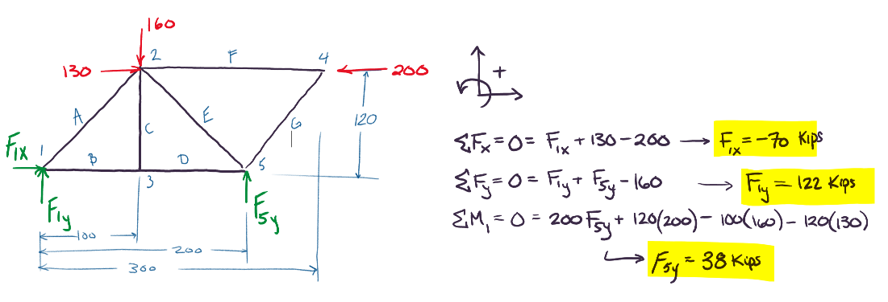

Figure - Iteration 1 Hand Calculations

Hand calculations for resultant forces were done using the traditional statics method.

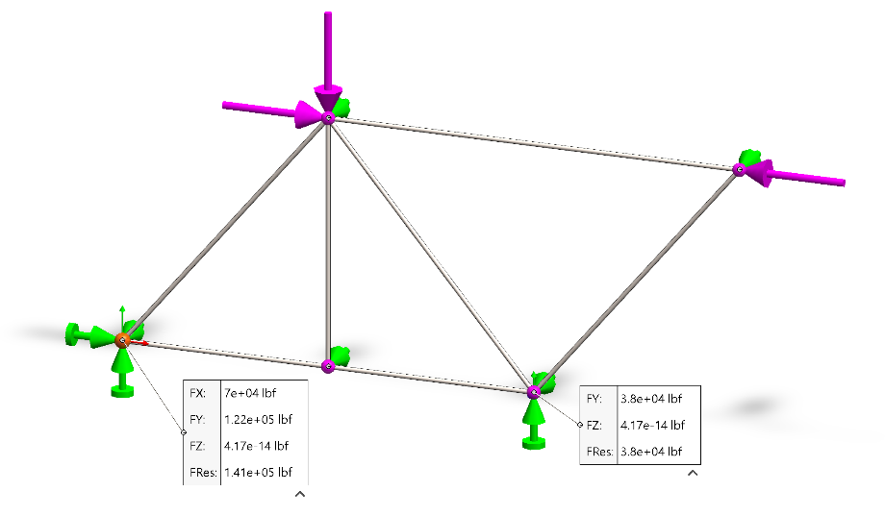

Figure - Iteration 1 SW Simulation Resultant Forces

Resultant forces were probed in SOLIDWORKS at nodes 1 and 5. Forces are shown in their X and Y components.

|  |  |  |  |  |  |  |
| --- | --- | --- | --- | --- | --- | --- |
| **Table 2 - Iteration 1 Direct Stiffness Validation** | | | | | | |
| **Node** | **MATLAB** | | **SOLIDWORKS** | | **% Difference** | |
|  | **ΔX (in)** | **ΔY (in)** | **ΔX (in)** | **ΔY (in)** | **X** | **Y** |
| **1** | 0 | 0 | 0 | 0 | 0% | 0% |
| **2** | -0.107941427 | -0.252667423 | -0.106 | -0.249 | -2% | -1% |
| **3** | 0.033599377 | -0.252667423 | 0.033 | -0.249 | -2% | -1% |
| **4** | -0.532354608 | 0.499627802 | -0.524 | 0.492 | -2% | -2% |
| **5** | 0.067198754 | 0 | 0.066 | 0 | -2% | 0% |
| **Element** | **σ (psi)** | | **σ (psi)** | | **% Difference** | |
| **A** | -50550 | | -50550.285 | | 0.001% | |
| **B** | 75800 | | 10079.812 | | -86.702% | |
| **C** | -1.8528E-11 | | 0 | | 0.000% | |
| **D** | 95960 | | 10079.812 | | -89.496% | |
| **E** | -15745 | | -15745.17 | | 0.001% | |
| **F** | -63662 | | -63661.977 | | 0.000% | |
| **G** | -1.158E-11 | | 0 | | 0.000% | |

Table 2 shows the displacement of each node and axial stress in each member. Values calculated using the direct stiffness method in MATLAB are compared to SOLIDWORKS simulation results.

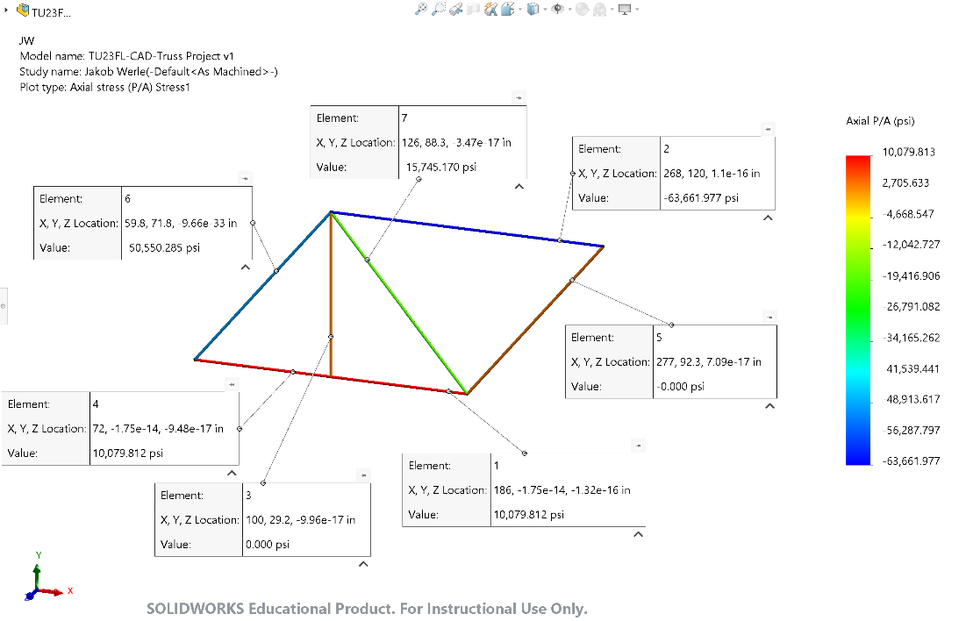

Figure - Iteration 1 SW Simulation Axial Stresses

Stresses were probed in each member during the SOLIDWORKS simulation.

|  |  |  |  |  |  |  |
| --- | --- | --- | --- | --- | --- | --- |
| **Table 3 – Nodal Displacements Per Design Iteration** | | | | | | |
| **Iteration 1** | | | | | | |
| **X oa (in)** | 300 | **Y oa (in)** | 120 | **Min FoS** | 1.413 | **Pass/Fail?** |
| **Node** | 1 | 2 | 3 | 4 | 5 | Fail |
| **ΔX (in)** | 0 | -0.106 | 0.033 | -0.524 | 0.066 | **Reason** |
| **% Diff** | 0.000% | -0.035% | 0.011% | -0.175% | 0.022% | All non-fixed nodes deflected more than allowed. |
| **ΔY (in)** | 0 | -0.249 | -0.249 | 0.492 | 0 |
| **% Diff** | 0.000% | -0.208% | -0.208% | 0.410% | 0.000% |
| **Iteration 2** | | | | | | |
| **X oa (in)** | 300 | **Y oa (in)** | 120 | **Min FoS** | 8.834 | **Pass/Fail?** |
| **Node** | 1 | 2 | 3 | 4 | 5 | Fail |
| **ΔX (in)** | 0 | -0.017 | 0.005 | -0.084 | 0.011 | **Reason** |
| **% Diff** | 0.000% | -0.006% | 0.002% | -0.028% | 0.004% | Nodes 2, 3, 4 deflection in Y. Node 4 deflection in X. |
| **ΔY (in)** | 0 | -0.04 | -0.04 | 0.079 | 0 |
| **% Diff** | 0.000% | -0.033% | -0.033% | 0.066% | 0.000% |
| **Iteration 3** | | | | | | |
| **X oa (in)** | 300 | **Y oa (in)** | 120 | **Min FoS** | 16.4 | **Pass/Fail?** |
| **Node** | 1 | 2 | 3 | 4 | 5 | Fail |
| **ΔX (in)** | 0 | 0.004 | -0.006 | -0.031 | -0.012 | **Reason** |
| **% Diff** | 0.000% | 0.001% | -0.002% | -0.010% | -0.004% | Nodes 2, 3 deflection in Y. Node 4 deflection in X. |
| **ΔY (in)** | 0 | -0.022 | -0.022 | -0.004 | 0 |
| **% Diff** | 0.000% | -0.018% | -0.018% | -0.003% | 0.000% |
| **Iteration 4** | | | | | | |
| **X oa (in)** | 300 | **Y oa (in)** | 120 | **Min FoS** | 16.4 | **Pass/Fail?** |
| **Node** | 1 | 2 | 3 | 4 | 5 | Fail |
| **ΔX (in)** | 0 | -0.005 | -0.015 | -0.049 | -0.03 | **Reason** |
| **% Diff** | 0.000% | -0.002% | -0.005% | -0.016% | -0.010% | Node 4 deflection in X |
| **ΔY (in)** | 0 | -0.002 | 0.004 | -0.006 | 0 |
| **% Diff** | 0.000% | -0.002% | 0.003% | -0.005% | 0.000% |
| **Iteration 5** | | | | | | |
| **X oa (in)** | 300 | **Y oa (in)** | 90 | **Min FoS** | 16.96 | **Pass/Fail?** |
| **Node** | 1 | 2 | 3 | 4 | 5 | Fail |
| **ΔX (in)** | 0 | -0.034 | -0.023 | -0.077 | -0.05 | **Reason** |
| **% Diff** | 0.000% | -0.011% | -0.008% | -0.026% | -0.017% | Nodes 2, 4 deflection in Y. Node 3, 4 deflection in X. |
| **ΔY (in)** | 0 | 0.004 | 0.017 | 0.023 | 0 |
| **% Diff** | 0.000% | 0.004% | 0.019% | 0.026% | 0.000% |
| **Iteration 6** | | | | | | |
| **X oa (in)** | 300 | **Y oa (in)** | 90 | **Min FoS** | 32.15 | **Pass/Fail?** |
| **Node** | 1 | 2 | 3 | 4 | 5 | Pass |
| **ΔX (in)** | 0 | -0.003 | -0.008 | -0.025 | -0.015 | **Reason** |
| **% Diff** | 0.000% | -0.001% | -0.003% | -0.008% | -0.005% | All nodes deflect less than 0.01%. Truss can support load. |
| **ΔY (in)** | 0 | -0.001 | 0.002 | -0.003 | 0 |
| **% Diff** | 0.000% | -0.001% | 0.002% | -0.003% | 0.000% |

Table 3 shows the nodal displacements for each iteration of the truss design. The X and Y displacements are shown as their nominal values and as percentages of the trusses overall width and height, respectively. Iterations with geometric parameters that failed to meet design criteria are highlighted red for readability.

Figure - Iterations 1 -6 of Truss Design

Figure 4 shows the overall design changes for each iteration of the truss.

Figure - Final Iteration X Deflection

Above is the X component of nodal displacement plot for the final iteration of the truss.

Figure - Final Iteration Y Deflection

Above is the Y component of nodal displacement plot for the final iteration of the truss.

Figure - Final Iteration Axial Stress

Above is the axial stress plot for each element in the final iteration of the truss.

Figure - Final Iteration Factor of Safety

Above is the factor of safety plot for the final iteration of the truss.

# Discussion

The goal of designing this truss was to support point loads, as seen in Figure 1 - Iteration 1 Hand Calculations, and minimize nodal deflection to less than 0.01% of the overall width and height of the truss. Multiple truss designs were tested and the final iteration was chosen when all design criteria were met. A theme though out this design process was to avoid choosing excessively large material to achieve the design criteria. It was typical to exhaust truss geometry choices before making a change to element cross sectional diameter. While more work, this gave more insight into how both geometry and size of truss elements can create a strong structure.

To begin the design process, hand calculations were done on the first iteration of the truss, as seen in Figure 1 - Iteration 1 Hand Calculations. Calculations were performed before running making any design changes to ensure the simulation provided correct results. In Table 1, resultant force hand calculations were compared to SOLIDWORKS simulation results. In Table 2, axial stresses that were calculated with MATLAB were compared to the SOLIDWORK simulation results. Both results show small deviance from hand calculations which confirms the functionality of the simulation. With a functional simulation, geometric changes could be made without changing simulations parameters.

For the first iteration of the truss design, an element diameter of 2 inches was chosen as a realistic material and strength criteria was met with a factor of safety of 1.4. As seen in Table 3, the first design did not pass for nodal deflection. In fact, all nodes moved significantly more than the allowable 0.01%.

The mode of failure seen in the first design encouraged an increase in diameter of each element to 5 inches. Using the same geometry, the simulation was ran again and nodal displacement was reduced significantly. All nodes were now deflecting less than 0.1%, which said that exploring truss geometry was now a reasonable option to increase truss stiffness.

In Figure 4 - Iterations 1 - 6 of Truss Design, it is shown that for the 3rd through 5th truss iterations were focused on finding a layout of elements that reduced the displacements of each node. A trend could be seen in Table 3 where the largest concerns were generally nodes 2 and 4, as they were taking a large amount of loads and were unsupported. By looking at stress plots such as Figure 7 - Final Iteration Axial Stress, efforts were made to utilize each member as much as possible. If it was determined that a member was underutilized, the geometry was changed so that the elements were more in line with the distribution of loads. Large improvements were made, as deflection was within tolerance except for one node by iteration 4. After the 5th iteration, it was apparent that the progress with geometry changes had hit diminishing returns, as nodal displacement increased significantly. This prompted another minor increase in element diameter.

For the final iteration, a cross sectional diameter of 7 inches was chosen, and as seen in Figure 4 - Iterations 1 - 6 of Truss Design, the geometry for iteration 4 was reused. Table 3 shows how all design criteria were now met. The resulting factor of safety was 32.2, which hints that there is likely room for improvement in this truss design. Moving forward, it is likely that cross sections of each member could be changed independently to reduce costs and weight of the truss while still meeting critical design goals.

# Summary

Using SOLIDWORKS Simulation, Statics theoretical analysis, and the direct stiffness method, a truss was designed with the established design criteria. The final truss fit within the required section of 16’ by 30’ rectangle and contained 7” diameter stock. The nodal displacements were less than 0.01% of the overall dimensions as given by the design criteria. In addition, the maximum stress was noy beyond yield stress for the material. For the project, unique truss geometry was explored to show proficiency in theoretical and simulation skills. To conclude, SOLIDWORKS simulation can be very helpful as a design tool, but should be validated through theoretical calculations to ensure validity of results.